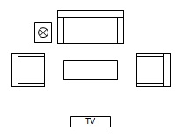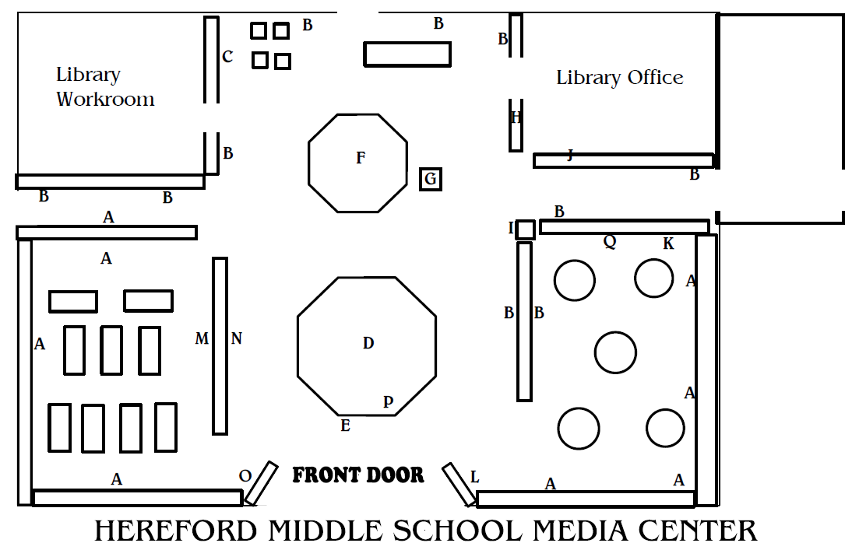

Circulation Desk

Desktop computers

Comfy Space for small group discussions or quite reading

Secondary Teaching Space

Collaboratorium (combination maker space & collaboration space)

Main Teaching Space